|  |  |
| --- | --- |
| No. of Pages | **4** |
| No. of Questions | **4** |

**Department of Computer Science and Engineering**

**MIDTERM EXAMINATION Fall 2013**

**CSE421/EEE 465: Computer Network**

**Total Marks: 60 Time Allowed: 60 minutes**



* Answer ALL **FOUR (4)** questions
* Figure in bracket [] next to each question indicates marks for that question



**Question No. 1**

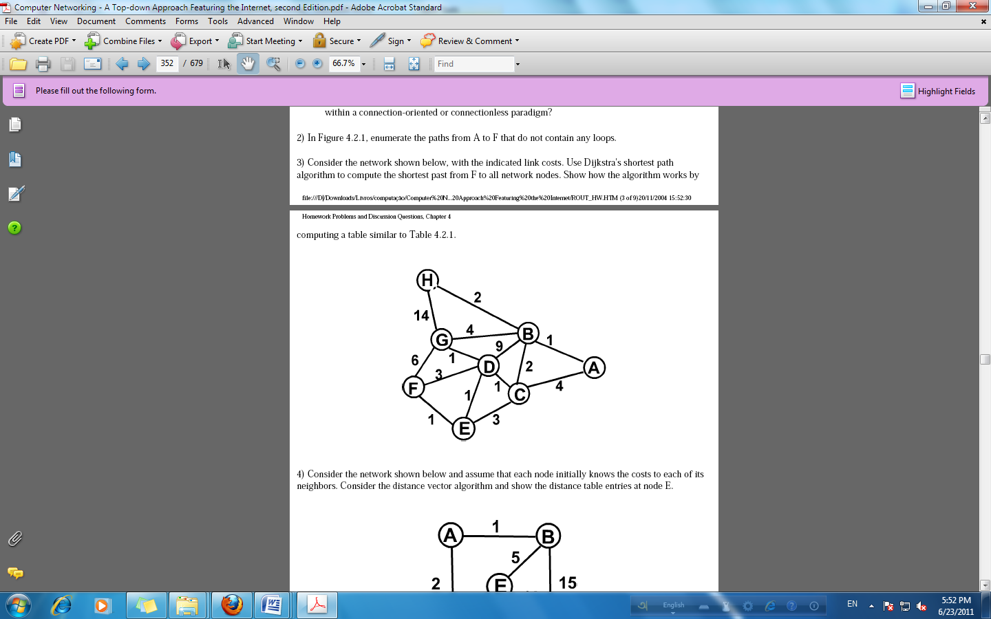

**Figure no. 1**

1. Consider the network shown above in figure 1, with the indicated link costs. Use Dijkstra's shortest path algorithm to compute the shortest past from **G** to all network nodes. Show how the algorithm works by computing a table. Use the provided table. [11 marks]
2. Explain how Split Horizon with Poison Reverse is used in avoiding loops? [4 marks]

**Question No. 2**

1. Referring to the diagram and output shown in figure no. 2 and figure no. 3, why does router R2 have two equal costs paths to 172.16.0.0 network? Diagram or topology shows otherwise. [4 marks]

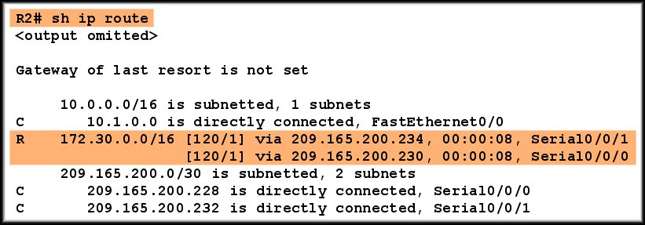

**Figure no. 2**

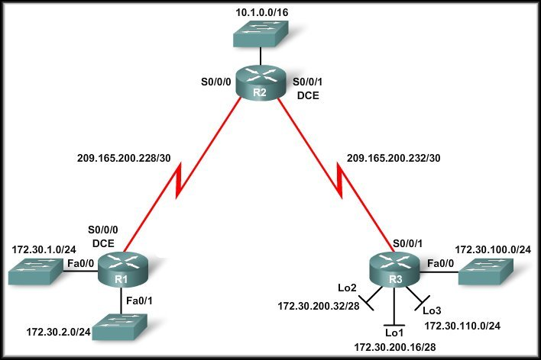

**Figure no. 3**

1. Refer to the output shown in figure no.4 below, Routers R1 and R2 are directly connected through a FastEthernet link but cannot form a neighbor adjacency. What could resolve the problem? [3 marks]

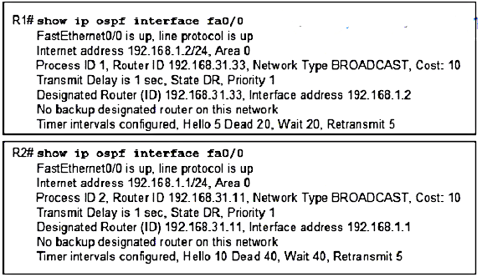

**Figure no. 4**

1. What criteria are used to choose a DR and BDR in the OSPF multi-access network? What should you do to the configuration of a router that you want to win the election for DR? [4 marks]
2. What is the purpose of the following two commands: [4 marks]
   1. default-information originate
   2. redistribute static

**Question 3**

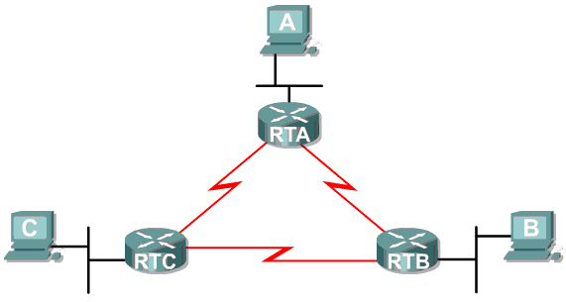

**Figure no. 5**

1. Referring to the network in figure no. 5 above, use VLSM to create an IP addressing scheme that wastes the least amount of address space. DON’T FORGET THE WAN LINKS!!
   * 1. Address space: **172.16.132.0/22**
     2. RTA has 200 hosts; RTB has 190 hosts; RTC has 80 hosts [8 marks]

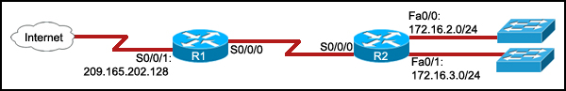

**Figure no. 6**

1. Refer to the exhibit shown in figure no. 6. The command **ip route 0.0.0.0 0.0.0.0 S0/0/0** is run on router R2. What are the two results of this command? [3 marks]
2. Static routes are better than dynamic routes, true or false? [4 marks]

**Question 4**

**P 192.168.1.0/24, 1 successors, FD is 3014400  
 via 192.168.10.10 (3014400/28160), Serial0/1  
 via 172.16.3.1 (41026560/2172416), Serial0/0**

**Figure no. 7**

1. These are entries from the topology table shown in figure no.7. Each of these entries has a name, what are they? What does the letter “P” signifies? [4 marks]
2. Compare EIGRP vs RIPV2. [4 marks]
3. Refer to the exhibit shown in figure no. 8. What will happen if interface Serial0/0/1 goes down on Router1? [3 marks]

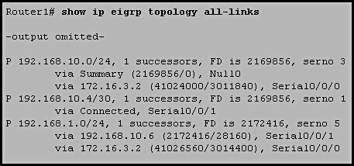

**Figure no. 8**

1. How does EIGRP support different network layer protocols? [4 marks]

**THE END**